**Introduction:**

**LandMark** is an innovative property management application that leverages the power of blockchain technology to ensure secure, transparent, and tamper-proof property transactions. Whether you're buying, selling, or bidding on properties, LandMark provides a seamless platform designed for trust and efficiency.

**Sign in**

This screen is the "**Sign In page**" for the LandMark application.

1. If you already have an account, enter your registered email address
2. Enter your password
3. Click the sign in button to move to the home page

If you don’t have an account, you can create your account with google or continue with apple to create your account, you can also choose the option

“Don’t have an account? Sign up here” to create your account with your own email and password

**Create an account**

This screen is the **"Create an Account"** page for the LandMark application.

1. After the user chooses this option, he will input his/her email address as the primary identifier for the account.
2. Users will enter a secure password to protect their account
3. Users re-enter the password to ensure accuracy.

There is also a small eye icons next to the password fields allow users to toggle between showing and hiding their password for convenience.

**Homepage**

This screen is the **"Homepage"** for the LandMark application.

After the user completes all the required procedures he will be moved to the homepage of the application. There is a search bar that Allows users to search for properties or related information.

If the user is a landlord, he can choose publish property button or section where landlords can list or manage properties they own for sale or auction.

The own lands bidding button Displays properties owned by the user with current bidding status:

* "Al Bustan Rotana" shows an auction status with a current bid of +1,600,000.
* "Villa in Jumeirah" shows a completed bidding status at 100%.

If the user is a buyer he can choose the buy property button where he can explore properties available for purchase.

**Profile page**

This screen is the **"profile page**” forthe LandMark application.

Users can reach this page from the homepage upper icons option, here users can do many things related to their account management

1. Edit their profile name or picture
2. Check for their notifications like bidding states or offers occurs
3. Choose the country they want to search for properties
4. If they are facing any problems they can ask for support like if they are facing any problems with the bidding process or payment process.
5. Invite friends by sharing the link of the application

**Buy property page**

This screen is the **"Buy property page**” forthe LandMark application.

This page can be accessed by both landlords or buyers, landlords or buyers are transferred to this page after they click on the buy property button from the homepage. Here you can search for the desired property and get more information’s about the property and there price, owner name and date of publishing.

After you look for a property you will have the option to add it to your cart and procced with the payment

**Publish property page**

This screen is the **"Publish property page**” forthe LandMark application.

his GUI allows landlords to publish properties for listing. They can upload an image, enter the property's name and description, and select a category (e.g., villa, apartment, land, house, or beach villa). Landlords can also set a starting price and a sale price. Once all details are filled in, they can click the "Create Product" button to post the property.

**Cart page**

This screen is the **"Cart page**” forthe LandMark application.

This GUI shows the buyer's shopping cart and order summary before proceeding to payment. It lists the selected properties with their names, images, and prices. Buyers can remove items from the cart using the delete icon. The order summary includes a price breakdown showing the base price, applicable taxes, and the total amount. Once the buyer reviews the details, they can click the "Continue to Checkout" button to proceed with payment.

**Final payment page**

This screen is the **"Final payment page**” forthe LandMark application.

The payment page allows the buyer to finalize their purchase by entering payment details. It displays the total amount due and includes fields for the cardholder name, card number, expiration date, and CVC code. Buyers can also choose to save their card information for future use by toggling the provided switch. After reviewing the details, they can proceed with the transaction by clicking the "Pay Now" button.

the full code of the application Is submitted in another file in BB

NOW for our block chain system here is a brief shots about it and its code and some functinalties:

***-Blockchain Consensus and State Updates Logs***

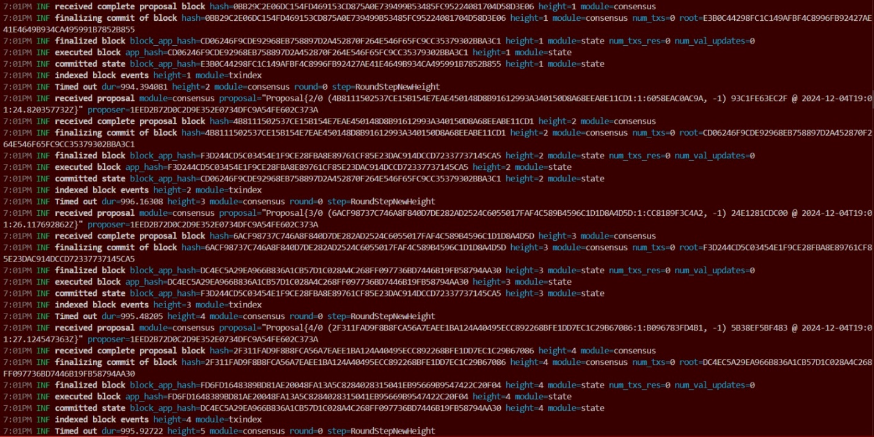

The log captures a blockchain node processing consensus rounds, finalizing blocks, updating states, and indexing events, highlighting operations like proposal acceptance, block execution, and timeout handling.

### **Setting and Resolving Blockchain Name Service Property**

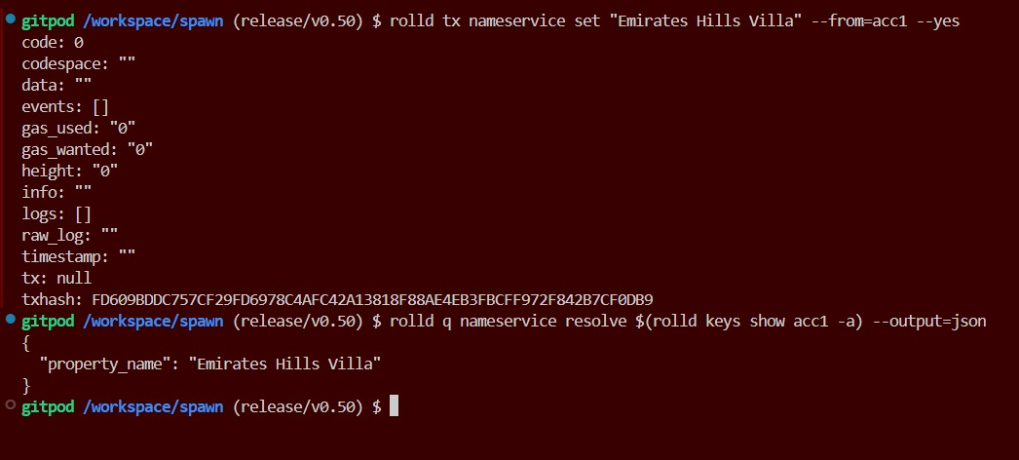

This code demonstrates a transaction to set a property name ("Emirates Hills Villa") in a blockchain-based name service and subsequently resolves the property to confirm its registration using the specified account.